**ACTIVITIES FOR THIS WEEK #4 (Chess pieces Practice)**

**Graphically Design your own Chess pieces. Attached are samples of Chess pieces.**

For Static Chess

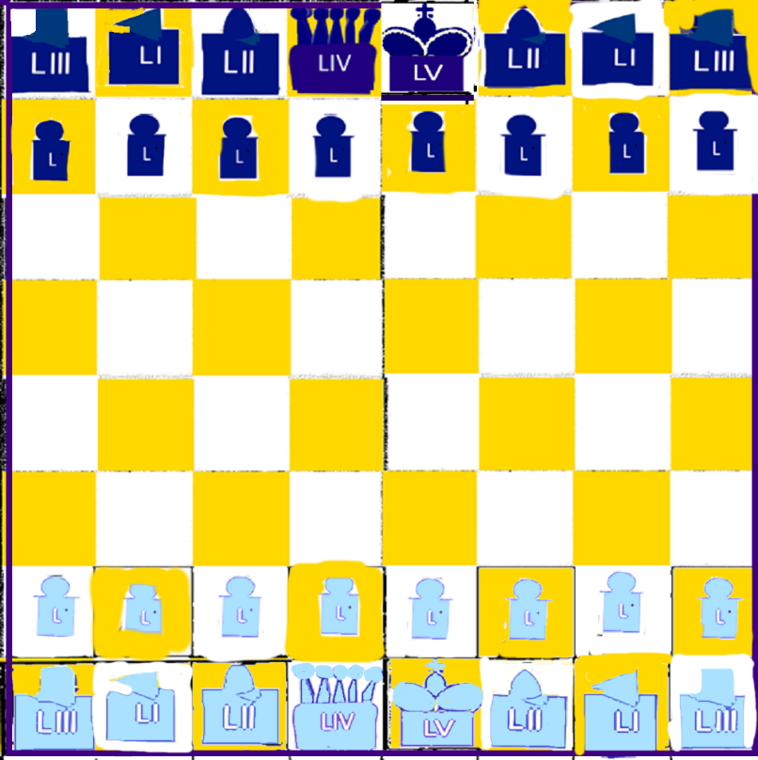

For Dynamic Chess

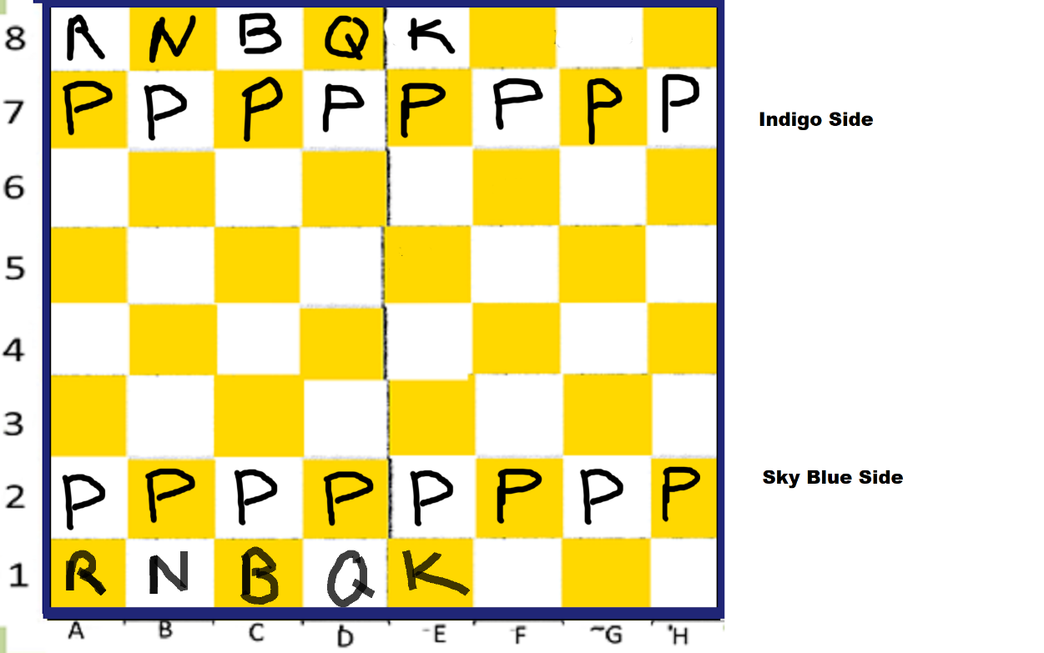

**#1 Practice with Static Chess.**

1. A – H **____________________**
2. 1 – 8 **____________________**
3. Golden Yellow and White **____________________**
4. A1 – A8 (vertical) **____________________**
5. A1 – H1 (horizontal) **____________________**

**#2 Probe with Binary** ____________________________________________________________________________________________________________________________________________________

__________________________________________________________________________

__________________________________________________________________________

__________________________________________________________________________

**#3 Practice with Dynamic Chess**

1. N or 1200 hrs ____________________
2. E or 1500 hrs ____________________
3. S or 1800 hrs ____________________
4. W or 2100 hrs ____________________
5. N or 2400 hrs ____________________