**ACTIVITIES FOR THIS WEEK #2 (Chessboard)**

**Graphically Design your own Chessboard. Attached is a sample below.**

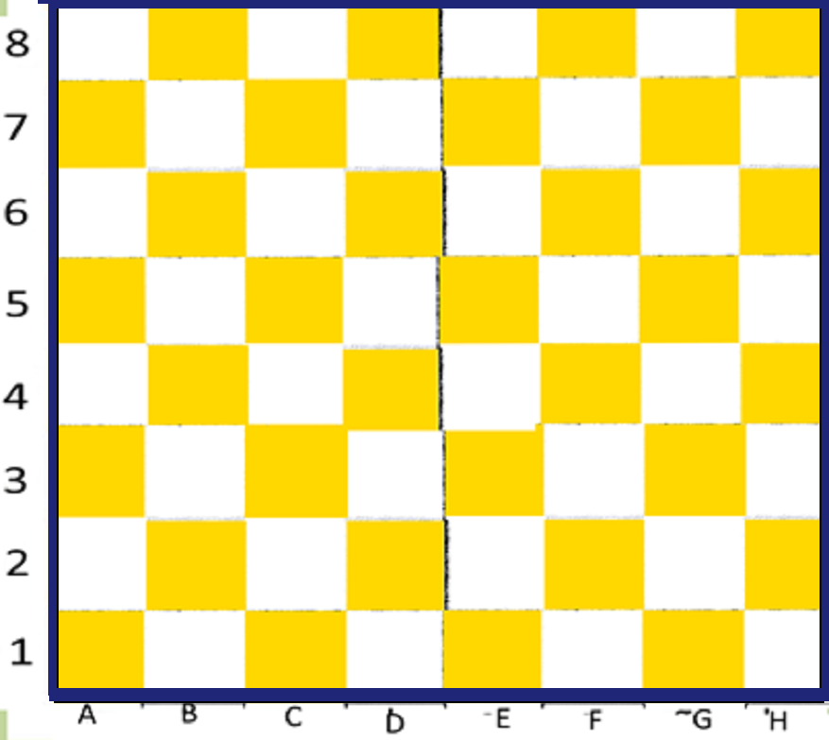

Mom’s Grassy Chessboard is Professor Deauna’s original. The Chessboard always points North in Dynamic Chess. Also, the Chessboard points changes clockwise in the Dynamic Chess from 1200 hrs (12:00 PM) to 1500 hrs (3:00 PM) to 1800 hrs (6:00 PM) to 2100hrs (9:00 PM) and to the 2400 hrs (12:00 AM) position.

Static Chess is regular Chess. Practice Static Chess using Mom’s Grassy Chessboard. Dynamic is different. This is Professor Deauna’s original. With a compass engage (play), engage the engagement (game) from North to East to South to West and to North again. The Chessboard is not moved. The engagers move accordingly.

Devoid of a compass, the engagers engage from 1200 hrs to 1500 hrs to 1800 hrs to 2100 hrs to 2400 hrs positions. The Chessboard is moved accordingly.

Probe means to investigate. Probe the STEM concepts with your binary.

**#1 Practice with Static Chess.**

1. A – H **____________________**
2. 1 – 8 **____________________**
3. Golden Yellow and White **____________________**
4. A1 – A8 (vertical) **____________________**
5. A1 – H1 (horizontal) **____________________**
6. **#2 Probe with Binary __________________________________________________________________________________________________________________________________________**

**_____________________________________________________________________**

**_____________________________________________________________________**

**_____________________________________________________________________**

**#3 Practice with Dynamic Chess**

1. N or 1200 hrs **____________________**
2. E or 1500 hrs **____________________**
3. S or 1800 hrs **____________________**
4. W or 2100 hrs **____________________**
5. N or 2400 hrs **____________________**