**ACTIVITIES FOR THIS WEEK #4 (Water and Evolutionary Medicine)**

**Overview**

According to Evolutionary Medicine Concepts, the Earth was hot originally and water existed only as water vapor. There was not a lot of water. Then, there was Global Cooling. This condition of Global Cooling allowed water to condense. Ergo, the water cycle was completed and precipation occurred. Using the “THREAD”, Connecting The Concepts of the Origin of Life from Activities Of Week #2, water made the monomers to evolve, water made the polymers to evolve, water made the protocells to evolve with Engineering Control, allowing the evolution of living cells (Professor Deauna).

**These are the following activities for this week. I revised the Activities For This Week to accommodate any Global Farmer-Engineer joining this course anytime. Also, I revised the Activities For This Week to accommodate any Health Care Provider joining this course anytime as a refresher course. Furthermore, I revised the Activities For This Week by adding laboratory exercises every week.**

**I. Discussion Forum Activities**

**Discussion Forum Activity –**

The Global Farmer Engineers should answer the questions in the Discussion Forum. The Discussion Forum consists of two parts. The first part will be your response to the main question(s). The second part will be your response to your binary.

Answer the Discussion Forum questions for the week by posting to your binary. For Part 1, Military Checkpoint (MC) #1: What are hydrogen bonds?; Military Checkpoint #2: “What are the properties of water?” For Part 2, Evolutionary Medicine Concept states ice is less dense than liquid water. Ergo, ice floats on water. What did the ice that formed above the lakes provided for the living organisms in the water?

**II. CONNECTING THE CONCEPTS and Binary Project Paper**

**CONNECTING THE CONCEPTS**

The CONNECTING THE CONCEPTS exercises identify the need to integrate the concepts through the course. You will recognize that learning the concepts is not based upon memorization. Instead, learning the concepts is based on connecting and linking the concepts even if it seems to be of different topics. Let me explain, the CONNECTING THE CONCEPTS exercises act as the threads that unite the concepts throughout the course. You will be using the CONNECTING THE CONCEPTS exercises when you build your Binary Project Paper.

There are five concepts that you have to use in sentences every week. Connecting The Concepts exercise is a critical thinking exercise I designed and I have been using Connecting The Concepts for 30 years now. The five concepts for this week are:

**1. Buffers**

**2. Solutions**

**3. Primordial soup**

**4. Hydrothermal vents**

**5. Electronegativity**

Post your responses by sending your sentences to your binary.

**Binary Project Paper –** Plan your work and create your paper with regards to describing the evolutionary process of photosynthesis, describing how electron flows evolved in the light reactions, describing how plant evolved to fix carbon dioxide, explaining the importance of the evolutionary process that evolved in the Calvin cycle, and explaining Photosynthesis and Food Production for all. The binaries are assigned according to the colors of the rainbow. The colors of the rainbow are Red, Orange, Yellow, Green, Blue, Indigo, and Violet. (ROY-G-BIV). Because a Squad is composed of 10 Global Farmer-Engineers, the colors are Red, Orange, Yellow, Green, and Blue.

You have to research and write a paper on Photosynthesis before the end of this course. Updates will be given every week. The binary will use the five colors of the rainbow if a squad will be formed. The Binary Project Paper is due on 12/12.

For this week, your focus for your binary project paper is **to research and to download a picture of photosynthesis** using the Open Educational Resources**.**

**III. Laboratory Exercises and Evolutionary Video Exercises**

This is the revision I made. The laboratory exercise is another application of Global Farmer Engineer’s knowledge, in which the Global Farmer-Engineer’s will design and build a scientific report. The Global Farmer-Engineers will have the opportunity to create a scientific report and provide evidence to back their conclusions. Originally, I just gave the Objective (O) for the Laboratory Exercise. Then, I revised it and gave you the Materials (M) and Procedures (P). The Result ( R ) you have to produce.. The Conclusion ( C ) you have to make with you binary. This is the O – M – P – R – C format I designed 30 years ago.

**Laboratory Exercise #4**

**Objective**

I will be able to explain the picture (ETP) of the Chemistry of Water.

**Materials**

Professor Deauna’s lecture, Open Educational Resources Journals, Cellphone, and outside source [2.2 Water - Biology 2e | OpenStax](https://openstax.org/books/biology-2e/pages/2-2-water) 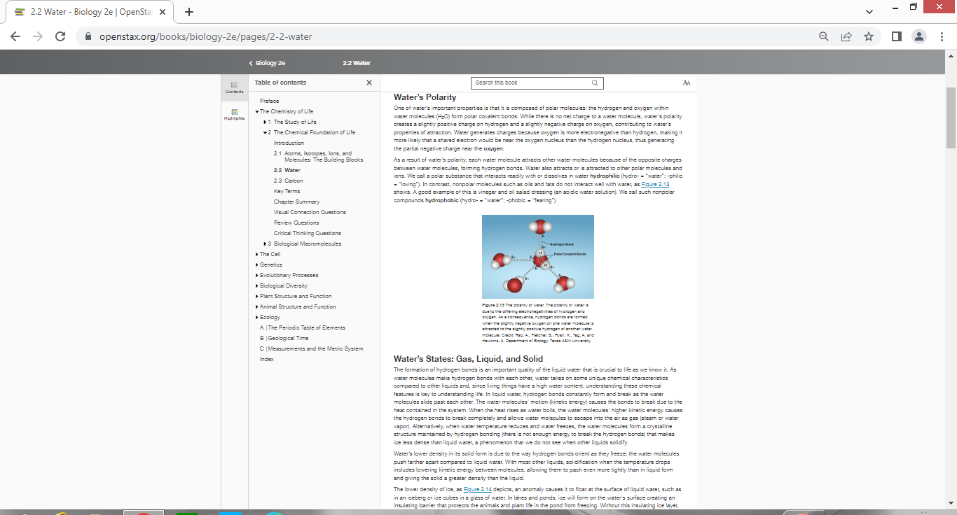.

**Procedures**

1. I will review what hydrogen bond is.

2. I will review, compare, and contrast high heat capacilty and high heat evaporation.

3. I will review what “solutions” are.

4. I will review, compare, and contrast adhesion and cohesion.

5. I will explain the picture (ETP) of the Chemistry of Water.

6. I will record my data, which are my results.

7. I will make my conclusion with my binary.

8. I will discuss my conclusion with my binary.

**Result (s)**

**Conclusion**

Make your conclusion with your binary.

**Evolutionary Medicine A&B Video Exercise**

There are also the Evolutionary Medicine A&B video exercises that the Global Farmer-Engineers must watch. The Evolutionary Medicine A&B exercise videos are aligned with the weekly objectives as presented in the syllabus. The Evolutionary Medicine A&B videos are videos that provide relevant and applied approach that will allow the Global Farmer-Engineers to relate Evolutionary Medicine concepts to their daily lives and to the production of food. Also, the Evolutionary Medicine A&B videos will provide the Global Farmer-Engineers with engaging stories about Evolutionary Medicine as applied to real world situations and problems.

Watch Evolutionary Medicine A Video on **The Evolution of Buffer systems** and Evolutionary Medicine B Video on **Acids and Bases.** Summarize each video in five sentences. Work with your binary.

**Open Questions:** E-mail your questions at [numbers115@aol.com](mailto:numbers115@aol.com).

**E-mail me your questions at numbers115@aol.com. Questions can be Prayer Requests and why. Questions can be related to College Sciences Concepts. Questions can be pertaining to the Monkeypox Virus. Questions can be on how to produce rice for all. Finally, questions can be on the Grassy Farmlands Nuclear Bunkers Rice Complexes and Universities.**

Do your best!

**Professor Deauna**