**ACTIVITIES FOR THIS WEEK #2 (Life and Origin of Life)**

**Overview**

To survive, an organism should maintain homeostasis. Homeostasis is the state of “balance”. Organisms evolved with feedback and mechanisms to maintain homeostasis. All the systems (same concept as the Grassy’s Chain of Command) contribute to homeostasis. Let me explain, there are feedback that maintain homeostasis either as negative feedback or positive feedback. Negative feedback is feedback that result in fluctuation below or above the normal. With regards to positive feedback, positive feedback is the mechanism that change in the same direction. Let me give an example, during delivery, contraction means pain. More contractions means more pain until the fetus is delivered (Professor Deauna).

**These are the following activities for this week. I revised the Activities For This Week to accommodate any Global Farmer-Engineer joining this course anytime. Also, I revised the Activities For This Week to accommodate any Health Care Provider joining this course anytime as a refresher course.**

**I. Discussion Forum Activities**

**Discussion Forum Activity –**

The Global Farmer Engineers should answer the questions in the Discussion Forum. The Discussion Forum consists of two parts. The first part will be your response to the main question(s). The second part will be your response to your binary.

Answer the Discussion Forum questions for the week by posting to your binary. For Part 1, Military Checkpoint (MC) #1: Define homeostasis; Military Checkpoint #2: “Discuss negative and positive feedback.” For Part 2, Evolutionary Medicine concept states that life originated 3.5 billion years ago (BYA), from non-living matter. Discuss the four stages of the origin of life with your binary.

**II. CONNECTING THE CONCEPTS and Binary Project Paper**

**CONNECTING THE CONCEPTS**

The CONNECTING THE CONCEPTS exercises identify the need to integrate the concepts through the course. You will recognize that learning the concepts is not based upon memorization. Instead, learning the concepts is based on connecting and linking the concepts even if it seems to be of different topics. Let me explain, the CONNECTING THE CONCEPTS exercises act as the threads that unite the concepts throughout the course. You will be using the CONNECTING THE CONCEPTS exercises when you build your Binary Project Paper.

There are five concepts that you have to use in sentences every week. Connecting The Concepts exercise is a critical thinking exercise I designed and I have been using Connecting The Concepts for 30 years now. The five concepts for this week are:

**1. Theory of Evolution**

**2. Metabolism**

**3. Radioactive dating**

**4. Plate tectonics**

**5. Binomial nomenclature**

Post your responses by sending your sentences to your binary.

**Binary Project Paper –** Plan your work and create your paper with regards to describing the evolutionary process of photosynthesis, describing how electron flows evolved in the light reactions, describing how plant evolved to fix carbon dioxide, explaining the importance of the evolutionary process that evolved in the Calvin cycle, and explaining Photosynthesis and Food Production for all. The binaries are assigned according to the colors of the rainbow. The colors of the rainbow are Red, Orange, Yellow, Green, Blue, Indigo, and Violet. (ROY-G-BIV). Because a Squad is composed of 10 Global Farmer-Engineers, the colors are Red, Orange, Yellow, Green, and Blue.

You have to research and write a paper on Photosynthesis before the end of this course. Updates will be given every week. The binary will use the five colors of the rainbow if a squad will be formed. The Binary Project Paper is due on 12/12.

For this week, your focus for your binary project paper is **learning the MLA format**. Work with your binary.

**III. Sample Laboratory Exercises and Evolutionary Video Exercises**

This is the revision I made. The laboratory exercise is another application of Global Farmer Engineer’s knowledge, in which the Global Farmer-Engineer’s will design and build an experiment. The Global Farmer-Engineers will have the opportunity to create a scientific report and provide evidence to back their conclusions. I will give the OBJECTIVE/S. The Global Farmer Engineer should decide on the materials, make the step by step procedures that will produce result/s. From the result/s, the Global Farmer-Engineer, with his binary, will make their own conclusion.

**Laboratory Exercise #2**

**Objective**

I will be able to identify and state the functions of the parts of a compound light microscope.

**Materials (Sample)**

Professor Deauna’s lecture, Open Educational Resources Journals, Cellphone, and outside source (Parker, Nina, et al.

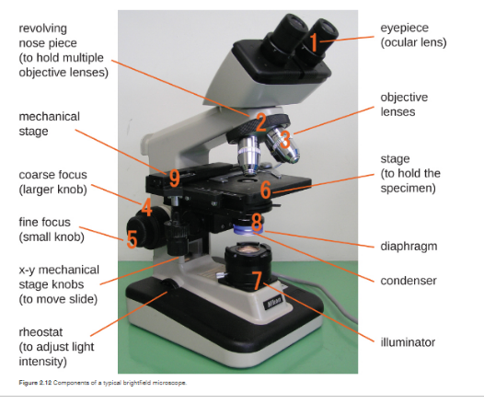

Microbiology, OpenStax, 2018).

**Procedures (Sample)**

1. I will review and identify the different parts of a compound light microscope.

2. I will describe the parts of the compound light microscope.

3. I will correlate the parts of the compound light microscope with the linked video on the internet.

4. I will correlate the parts of the compound light microscope with the illustration accompanying this experiment. I will discuss the parts of the compound light microscope with my binary.

5. I will record my results.

6. I will make my conclusion with my binary.

7. I will start a discussion regarding the microscope with my binary.

1. Ocular Lens – lens nearest the eye

2. Nose Piece – permits interchange of power objectives

3. Objective Lenses – contain lenses of different magnification

4. Coarse Focus – changes distance between slide and objective lens.

5. Fine Focus – permits exact focusing

6. Stage – support slides

7. Illuminator – provides light source

8. Diaphragm – regulates the amount of light

9. Mechanical Stage – holds the slide in place

**Result**

Describe the function of

1. Ocular Lens –

2. Nose Piece –

3. Objective Lens –

4. Coarse Focus –

5. Fine Focus –

6. Stage –

7. Illuminator –

8. Diaphragm –

9. Mechanical Stage–

**Conclusion**

Make your conclusion with your binary.

**Evolutionary Medicine A&B Video Exercise**

There are also the Evolutionary Medicine A&B video exercises that the Global Farmer-Engineers must watch. The Evolutionary Medicine A&B exercise videos are aligned with the weekly objectives as presented in the syllabus. The Evolutionary Medicine A&B videos are videos that provide relevant and applied approach that will allow the Global Farmer-Engineers to relate Evolutionary Medicine concepts to their daily lives and to the production of food. Also, the Evolutionary Medicine A&B videos will provide the Global Farmer-Engineers with engaging stories about Evolutionary Medicine as applied to real world situations and problems.

Watch Evolutionary Medicine A Video on **Homeostasis** and Evolutionary Medicine B Video on The **Theory of Evolution**. Summarize each video in five sentences. Work with your binary.

**Open Questions:** E-mail your questions at [numbers115@aol.com](mailto:numbers115@aol.com).

**E-mail me your questions at numbers115@aol.com. Questions can be Prayer Requests and why. Questions can be related to College Sciences Concepts. Questions can be pertaining to the Monkeypox Virus. Questions can be on how to produce rice for all. Finally, questions can be on the Grassy Farmlands Nuclear Bunkers Rice Complexes and Universities.**

Do your best!

**Professor Deauna**