**WEEK #19 Applied Laboratory Exercise on Food Production**

**I. Overview**

The binary is encouraged to critically think Evolutionary Medicine and Photosynthesis. I am willing to answer your additional questions regarding Evolutionary Medicine and Photosynthesis concepts. This activities will be done by you and your binary completely. Let me explain, you have to “design” and “build” your own O-M-P-R-C scientific method. You have to make your own objective based on the picture I attached with this applied laboratory exercise. You have to list all your materials. You have to enumerate your procedures. You have to record your data and produce your results. Finally, you have to make your own conclusion based on your results. Although the majority of plants are the C3 plants, there are C4 plants that utilizes the RUBP carboxylase enzyme to fix carbon dioxide. Also, there are crassulacean-acid metabolism (CAM) plants, which evolved with “time” and fixed carbon dioxide according to day and night. These different kind of photosynthesis gave us the Evolutionary Medicine concept of adaptation clearly. This Evolutionary Medicine concept of Adaptation can be used by humans to produce “more” food (Professor Deauna).

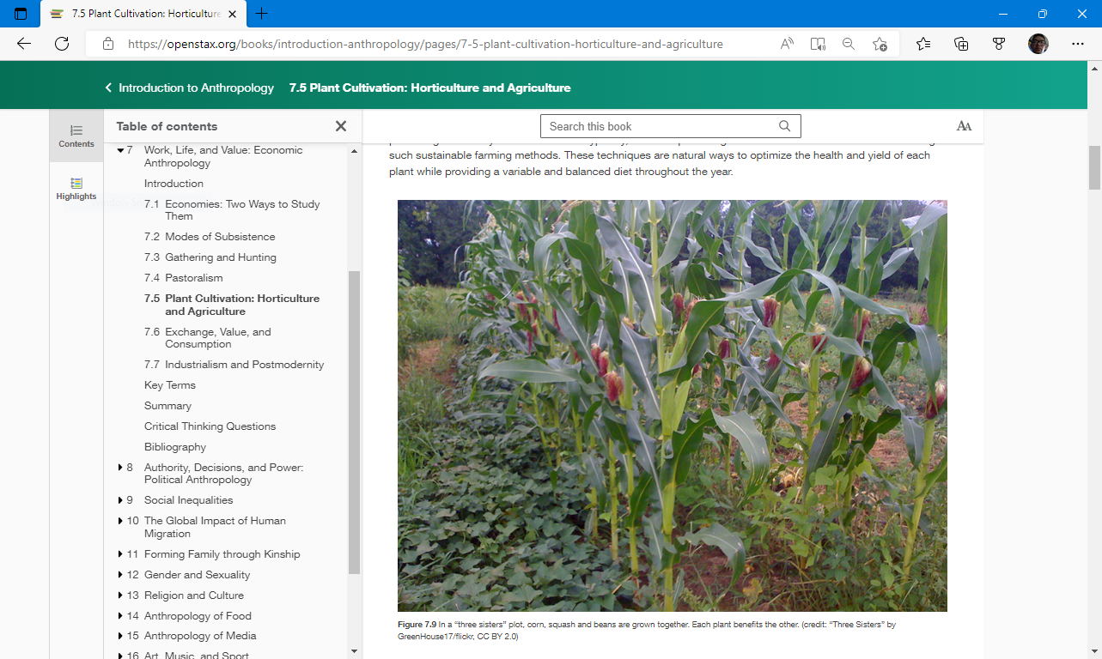

Do your best!

**Professor Deauna**

Applied Laboratory Exercise on Food Production

**Objective**

I will be able to…

**Materials**

Professor Deauna’s lecture, OER (cite your source)…

**(Picture)**

**Procedures**

1. I will review…

2. I will review…

3. I will review…

4. I will review…

5. I will review…

6. I will explain the picture (ETP)…

7. I will record…

8. I will make…

**Result/s**

**Conclusion**