**WEEK #18 Applied Laboratory Exercise on Photosynthesis**

**I. Overview**

The binary is encouraged to critically think Evolutionary Medicine and Photosynthesis. I am willing to answer your additional questions regarding Evolutionary Medicine and Photosynthesis concepts. This activities will be done by you and your binary completely. Let me explain, you have to “design” and “build” your own O-M-P-R-C scientific method. You have to make your own objective based on the picture I attached with this applied laboratory exercise. You have to list all your materials. You have to enumerate your procedures. You have to record your data and produce your results. Finally, you have to make your own conclusion based on your results. The plants cannot use all the wavelengths of light. However, by having evolved pigments the different colors, the plant is able to capture wavelengths more than the chlorophyll thus. Ergo, the colors of the rainbow, which evolved to be involved in photosynthesis varies in its energy content and varies in its wavelength as well (Professor Deauna).

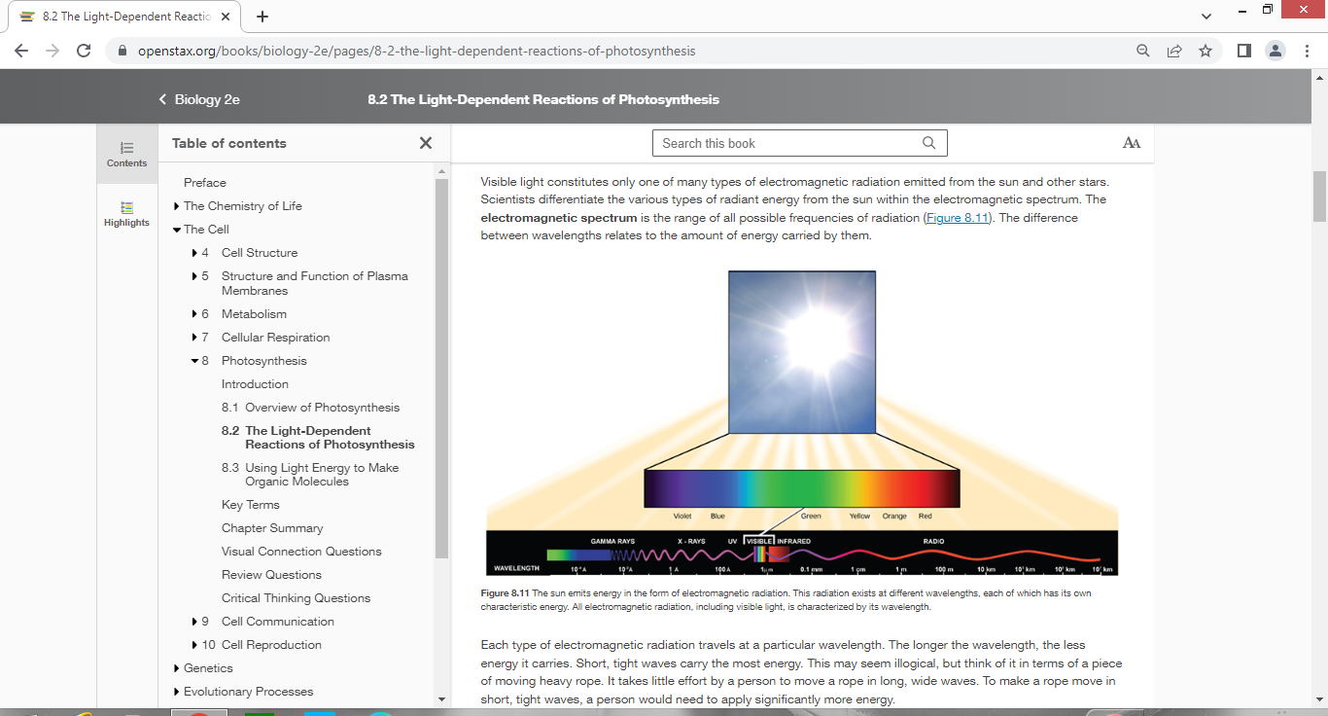

Do your best!

**Professor Deauna**

Applied Laboratory Exercise on Photosynthesis

**Objective**

I will be able to…

**Materials**

Professor Deauna’s lecture, OER (cite your source)…

**(Picture)**

**Procedures**

1. I will review…

2. I will review…

3. I will review…

4. I will review…

5. I will review…

6. I will explain the picture (ETP)…

7. I will record…

8. I will make…

**Result/s**

**Conclusion**