**ACTIVITIES FOR THIS WEEK #15 Photosynthesis**

**Overview**

The process of photosynthesis shows that photosynthesis is an oxidation-reduction reaction. The coenzyme NaDP+ is active. During photosynthesis, NADPH reduces the substrates. Oxidation-reduction reactions are a major process in which transformations of energy happens in the cells. Electron transport chain is used in photosynthesis. The electrons are transferred from one carrier to the next. This results in release of energy that is used to produce ATP molecules. In the chloroplasts, the carriers of the electron transport chain are located within the thylakoid membrane.

It is in the thylakoid membrane that the light reactions occur. Here the noncyclic electron pathway of the light reactions start when the energy from the sun enters Photosystem II (PSII) and energizes electrons in the chlorophyll a. The oxidation of water replaces the involved electrons in the reaction-center. Eventually, oxygen is released and hydrogen ions (H+) remain in the thylakoid space. Electrons are finally passed to Photosystem I. The electrons passed through an electron transport chain (ETC) and hydrogen ions are pumped across the thylakoid membrane.

Chemiosmosis is created and is made possible by the highly organized thylakoid membrane. The energized electrons are captured by NADP+, mentioned above and combined with H+ to become NADP. With regards to the cyclic pathway, the pathway has flow of electrons that pumps more hydrogen ions. The resulting flow of H+ provide kinetic energy that allows a synthase complex enzyme to speed up a reaction that produces ATP. This is how ATP is produced.

The energy produced in the light reaction is stored in NADPH and ATP. The NADPH and the ATP are used by the Calvin cycle reactions in a reduction of carbon dioxide to carbohydrate. This is the reduction to a glyceraldehyde-3-phosphate. The enzyme RuBP carboxylase fixes carbon dioxide to RuBP (Ribulose-1, 5 biphosphate), a 5-carbon molecule resulting 6-carbon molecule. This 6 carbon molecule breaks down to 2 C3 molecules. The next stage is carbon dioxide being reduced to carbohydrate. Energy is required so NADPH and ATP are used. The mathematics is that for every three turns, the gain is only one glyceraldehyde-3 phosphate (G3P). The remaining five molecules are used to form three molecules of RuBP. These reactions also require energy. Ergo, it takes 2 G3P molecules to make one and only one glucose molecule.

G3P is the product of the Calvin cycle. This G3P can be converted to other organic molecules. Glucose phosphate can be combined to form sucrose. Glucose phosphate is used for starch and cellulose formation. A plant uses the hydrocarbon G3P to form glycerol and fatty acids. The formation of glycerol and fatty acids results in the sunflower oil, corn oil, and olive oil used for cooking food. Finally, the addition of nitrogen to the G3P’s hydrocarbons leads to the productions of amino acids. Amino acids are the building blocks of protein.

Knowledge of photosynthesis can solve the problem of food shortage. Let me explain, how knowledge of photosynthesis can increase food production. Photosynthesis is not efficient in harvesting solar energy. So, if efficiency is increased, food production will be increased as well. This will solve the food crisis globally.

A solution in increasing food production is speeding up the intake of solar energy. Another solution is increasing Rubisco’s efficiency by altering the pathway of photorespiration and therefore, energy is saved. Also, the science of genetics can be used by improving crop’s genes, allowing the best plants with best photosynthetic capability to be used and made available to the farmers.

Finally, the knowledge of C3 and C4 photosynthesis can be used for increasing food production. I am working with a project related to C3 photosynthesis and C4 photosynthesis. It is related to developing a C4 Rice that can feed billions. C4 rice research will improve photosynthesis capacity. Rice has a C3 photosynthetic pathway, which is inefficient. Ergo, a C4 pathway is more efficient and will convert into more rice production. Rice is the staple food of more than 50 percent of the world’s population. A C4 Rice will alleviate world hunger and food shortage for now and the near future (Professor Deauna).

**These are the following activities for this week. I revised the Activities For This Week to accommodate any Global Farmer-Engineer joining this course anytime. Also, I revised the Activities For This Week to accommodate any Health Care Provider joining this course anytime as a refresher course. Furthermore, I revised the Activities For This Week by adding laboratory exercises every week.**

**I. Discussion Forum Activities**

**Discussion Forum Activity –**

The Global Farmer Engineers should answer the questions in the Discussion Forum. The Discussion Forum consists of two parts. The first part will be your response to the main question(s). The second part will be your response to your binary.

Answer the Discussion Forum questions for the week by posting to your binary. For **Part 1**, **Military Checkpoint (MC) #1**: What is the 1st Law of Thermodynamics? **Military Checkpoint #2**: “What is the 2nd Law of Thermodynamics?” For **Part 2**, Evolutionary Medicine Concepts state that each energy in the cell lead to “more” entropy. If less energy is available to do work, then what will be the condition needed by the cells of living organisms to survive?

**II. CONNECTING THE CONCEPTS and Binary Project Paper**

**CONNECTING THE CONCEPTS**

The CONNECTING THE CONCEPTS exercises identify the need to integrate the concepts through the course. You will recognize that learning the concepts is not based upon memorization. Instead, learning the concepts is based on connecting and linking the concepts even if it seems to be of different topics. Let me explain, the CONNECTING THE CONCEPTS exercises act as the threads that unite the concepts throughout the course. You will be using the CONNECTING THE CONCEPTS exercises when you build your Binary Project Paper.

There are five concepts that you have to use in sentences every week. Connecting The Concepts exercise is a critical thinking exercise I designed and I have been using Connecting The Concepts for 30 years now. The five concepts for this week are:

**1. Charophytes**

**2. Ordovicion period**

**3. Electromagnetic spectrum**

**4. Thylakoid membrane**

**5. Photorespiration**

Post your responses by sending your sentences to your binary.

**Binary Project Paper –** Plan your work and create your paper with regards to describing the evolutionary process of photosynthesis, describing how electron flows evolved in the light reactions, describing how plant evolved to fix carbon dioxide, explaining the importance of the evolutionary process that evolved in the Calvin cycle, and explaining Photosynthesis and Food Production for all. The binaries are assigned according to the colors of the rainbow. The colors of the rainbow are Red, Orange, Yellow, Green, Blue, Indigo, and Violet (ROY-G-BIV). Because a Squad is composed of 10 Global Farmer-Engineers, the colors are Red, Orange, Yellow, Green, and Blue.

You have to research and write a paper on Photosynthesis before the end of this course. Updates will be given every week. The binary will use the five colors of the rainbow if a squad will be formed. The Binary Project Paper is due on 12/12.

For this week, your focus for your binary project paper is **to connect “more” food production concepts to your paper.**

**III. Laboratory Exercises and Evolutionary Video Exercises**

This is the revision I made. The laboratory exercise is another application of Global Farmer Engineer’s knowledge, in which the Global Farmer-Engineer’s will design and build a scientific report. The Global Farmer-Engineers will have the opportunity to create a scientific report and provide evidence to back their conclusions. Originally, I just gave the Objective (O) for the Laboratory Exercise. Then, I revised it and gave you the Materials (M) and Procedures (P). The Result ( R ) you have to produce.. The Conclusion ( C ) you have to make with you binary. This is the O – M – P – R – C format I designed 30 years ago.

**Laboratory Exercise #15**

**Objective**

I will be able to explain the picture (ETP) of the 1st and 2nd Laws of Thermodynamics.

**Materials**

Professor Deauna’s lecture, Open Educational Resources Journals, Cellphone, and outside source.[8.1 Overview of Photosynthesis - Biology 2e | OpenStax](https://openstax.org/books/biology-2e/pages/8-1-overview-of-photosynthesis)

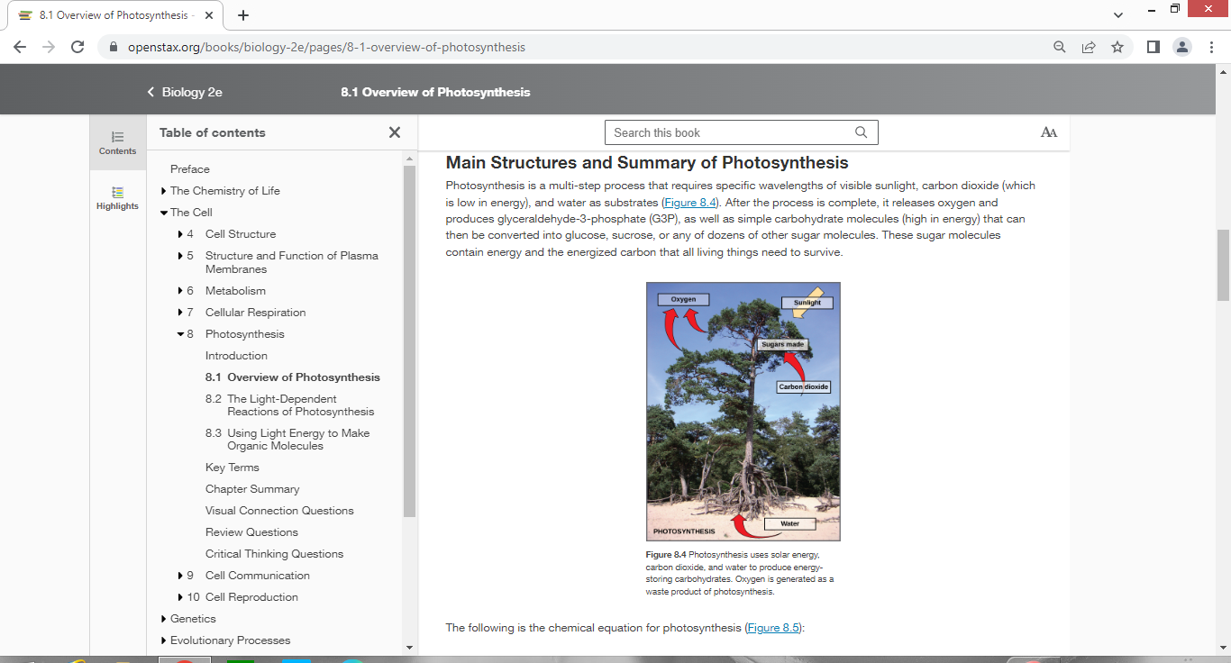

**Procedures**

1. I will review the light-dependent reactions.

2. I will review the light-independent reactions.

3. I will review the glucose phosphate molecule.

4. I will review the other types of photosynthesis.

5. I will review food production.

6. I will review rice production.

7. I will explain the picture of photosynthesis.

8. I will record my data, which are my results.

9. I will make my conclusion with my binary.

10. I will discuss my conclusion with my binary.

**Result (s)**

**Conclusion**

Make your conclusion with your binary.

**Evolutionary Medicine A&B Video Exercise**

There are also the Evolutionary Medicine A&B video exercises that the Global Farmer-Engineers must watch. The Evolutionary Medicine A&B exercise videos are aligned with the weekly objectives as presented in the syllabus. The Evolutionary Medicine A&B videos are videos that provide relevant and applied approach that will allow the Global Farmer-Engineers to relate Evolutionary Medicine concepts to their daily lives and to the production of food. Also, the Evolutionary Medicine A&B videos will provide the Global Farmer-Engineers with engaging stories about Evolutionary Medicine as applied to real world situations and problems.

Watch Evolutionary Medicine A Video on **Evolution of Land Plants** and Evolutionary Medicine B Video on **Evolution of Rice**.Summarize each video in five sentences. Work with your binary.

**Open Questions:** E-mail your questions at [numbers115@aol.com](mailto:numbers115@aol.com).

**E-mail me your questions at numbers115@aol.com. Questions can be Prayer Requests and why. Questions can be related to College Sciences Concepts. Questions can be pertaining to the Monkeypox Virus. Questions can be on how to produce rice for all. Finally, questions can be on the Grassy Farmlands Nuclear Bunkers Rice Complexes and Universities.**

Do your best!

**Professor Deauna**