**ACTIVITIES FOR THIS WEEK #7 (Central Nervous System/VOIAN Muscle that moves the leg-rectus femoris muscle)**

**Overview**

The nervous system evolved in humans and enable them to move. Humans, same as the other animals, move to seek food and to avoid dangers. The central nervous system (CNS) consists of the brain and the spinal cord. If it is brain and the spinal cord, it is the CNS. If not, then it is the peripheral nervous system (PNS).

There are three functions of the CNS. The three functions are receiving sensory input, integrating the sensory input, and developing motor outputs in response to the integrated data from the sensory input.

The nervous system is made up of nerve tissue. These nerve tissue in turn are made up of nerve cells (squares and circles). The nerve cells are the neurons. The neurons have three parts namely the dendrities, the cell body, and the axon. There is another kind of cell in the CNS. These cells are the neuroglia. The neuroglia are supporting cells, which I call the “nurse cells”. The neuroglia are also called the glial cells.

**These are the following activities for this week. I revised the Activities For This Week to accommodate any Global Farmer-Engineer joining this course anytime. Also, I revised the Activities For This Week to accommodate any Health Care Provider joining this course anytime as a refresher course.**

**A. Discussion Forum Activities**

**Discussion Forum Activity –**

The Global Farmer Engineers should answer the questions in the Discussion Forum. The Discussion Forum consists of two parts. The first part will be your response to the main question(s). The second part will be your response to your binary.

Answer the Discussion Forum questions for the week by posting to your binary. For Part 1, Military Checkpoint (MC) #1: What is the CNS? Military Checkpoint (MC) #2: What is the PNS?

For Part 2, Evolutionary Medicine concept states that the human nervous system involved with an enlarged forebrain due to the addition of a neocortex. For Part 2, answer the question, what is a neocortex?

**B. CONNECTING THE CONCEPTS**

The CONNECTING THE CONCEPTS exercises identify the need to integrate the concepts through the course. You will recognize that learning the concepts is not based upon memorization. Instead, learning the concepts is based on connecting and linking the concepts even if it seems to be of different topics. Let me explain, the CONNECTING THE CONCEPTS exercises act as the threads that unite the concepts throughout the course. You will be using the CONNECTING THE CONCEPTS exercises when you build your Binary Project Paper.

There are five concepts that you have to use in sentences every week. Connecting The Concepts exercise is a critical thinking exercise I designed and I have been using Connecting The Concepts for 30 years now. The five concepts for this week are:

**1. Central nervous system**

**2. Neuron**

**3. Neuroglia**

**4. “Outside the Box”**

**5. Rectus femoris**

Post your responses by sending your sentences to your binary.

**C. Binary Project Paper –** Plan your work and create your paper based on the Anatomy, the Physiology, the VOIAN, the Hazards, the Controls, and the Military Science concepts involved with the muscle chosen. With regards to the controls, the controls are Engineering Control, Administrative Control, and the use of Personal Protective Equipment. Military Concepts, which are Chess Concepts, are also included in your Binary Project Paper.

You have to research and write a paper on VOIAN and related concepts before the end of this course. Updates will be given every week. The Binary Project Paper is due on the Week of 7/15/24.

For this week, your focus for your binary project paper is **“threading the Concepts”. You have to make your own Connecting The Concepts for APEMS 201 by integrating relevant concepts for your paper.** Work with your binary.

**D. VOIAN Exercises and Laboratory Exercises and Evolutionary Video Exercises**

**VOIAN Exercises**

The **VOIAN Exercise** is my original that I made for my **Boston** Health Careers students. The **VOIAN Exercise** is related to **“dissections”** of the different muscles. The **VOIAN data** that you generated have to be **researched** with your binary. **V** stands for **view**. **O** stands for **origin** (the stationary part of the muscle). **I** is for **insertion** (the opposite end of the muscle that moves). **A** is for **action** (the movement caused by the muscle). Finally, **N** is for **nerve** (the nerve involved in the muscle). This assessment, like the other assessments, in this course, have corresponding rubrics attached to the syllabus to clearly state learning goals and objectives.

There is one movie or video that you have to watch. VOIAN exercises are aligned with the objectives of this course. Watch a movie or a video of your choice and the choice of your binary on the assigned muscle for this week. For this week, the assigned muscle is the **rectus femoris muscle**.

The **View** (V) is given. The **V** is right lateral.

**V = right lateral**

**O =**

**I =**

**A =**

**N =**

**Laboratory Exercise #7**

**Objective**

I will be able to explain the picture of (ETP) of the neuron.

**Materials**

Professor Deauna’s lecture, Open Educational Resources Journals, Cellphone, and outside

SOURCE: [Medical Microbiology - Microbiologynote.com](https://microbiologynote.com/microbiology/medical-microbiology/)

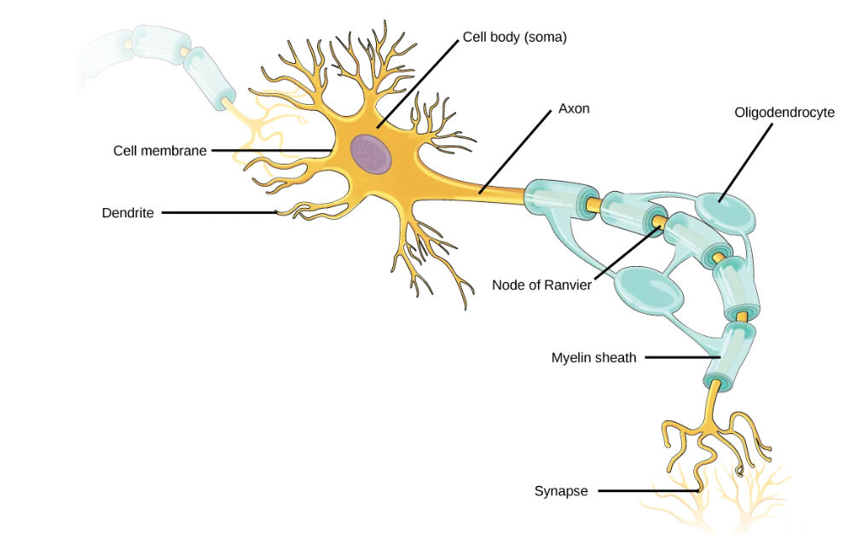

**Procedures**

1. I will review what a cephalization is.
2. I will review the vertebrate nervous system.
3. I will review the mammalian nervous system.
4. I will review the nerve tissue.
5. I will review the type of neurons.
6. I will explain the picture (ETP) of the neuron.
7. I will record my data, which are my results.
8. I will make my conclusion with my binary.
9. I will discuss my conclusion with my binary.

**Result**

**Conclusion**

Make your conclusion with your binary.

**Open Questions:** E-mail your questions at [numbers115@aol.com](mailto:numbers115@aol.com).

Questions can be related to APEMS (Anatomy, Physiology, Evolutionary Medicine and Military Science). Questions can be pertaining to COVID and other viruses. Questions can be on how to produce rice for all. Questions can be on Mom’s Grassy Farmlands Nuclear Bunkers Rice Complexes and Universities. Finally, questions can be on Mom’s Grassy “Extension”.

Do your best!

**Professor Deauna**