**ACTIVITIES FOR THIS WEEK #6 (Muscular System/VOIAN Muscle that moves the thigh—adductor magnus muscle)**

**Overview**

The human body is made up of almost 50% of muscle tissue. The muscle tissues are made up of cells (squares and circles) and evolved with the capability of contraction. The different muscle tissues are the smooth muscle, the skeletal muscle, and the cardiac muscle.

The smooth muscle is found in walls of the viscera (internal organs), is not under our control, with one nucleus, and is lacking striations. The skeletal muscle is the muscle that attach to bones, is under our control, with many nuclei per muscle fiber, and have striations. The cardiac muscle is the muscle located in the heart is not under our control, and is with muscle fibers that are branching, and is with one nucleus for every cell, and is with striations.

**These are the following activities for this week. I revised the Activities For This Week to accommodate any Global Farmer-Engineer joining this course anytime. Also, I revised the Activities For This Week to accommodate any Health Care Provider joining this course anytime as a refresher course.**

**A. Discussion Forum Activities**

**Discussion Forum Activity –**

The Global Farmer Engineers should answer the questions in the Discussion Forum. The Discussion Forum consists of two parts. The first part will be your response to the main question(s). The second part will be your response to your binary.

Answer the Discussion Forum questions for the week by posting to your binary. For Part 1, Military Checkpoint (MC) #1: What are muscle fibers? Military Checkpoint (MC) #2: What is a muscle contraction?

For Part 2, Evolutionary Medicine concept states that ATP evolved to provide energy for muscle contraction. For Part 2, answer the question, what is oxygen debt?

**B. CONNECTING THE CONCEPTS**

The CONNECTING THE CONCEPTS exercises identify the need to integrate the concepts through the course. You will recognize that learning the concepts is not based upon memorization. Instead, learning the concepts is based on connecting and linking the concepts even if it seems to be of different topics. Let me explain, the CONNECTING THE CONCEPTS exercises act as the threads that unite the concepts throughout the course. You will be using the CONNECTING THE CONCEPTS exercises when you build your Binary Project Paper.

There are five concepts that you have to use in sentences every week. Connecting The Concepts exercise is a critical thinking exercise I designed and I have been using Connecting The Concepts for 30 years now. The five concepts for this week are:

**1. Locomotion**

**2. Tetany**

**3. Neuromuscular junction**

**4. Calcium ion**

**5. Adductor magnus muscle**

Post your responses by sending your sentences to your binary.

**C. Binary Project Paper –** Plan your work and create your paper based on the Anatomy, the Physiology, the VOIAN, the Hazards, the Controls, and the Military Science concepts involved with the muscle chosen. With regards to the controls, the controls are Engineering Control, Administrative Control, and the use of Personal Protective Equipment. Military Concepts, which are Chess Concepts, are also included in your Binary Project Paper.

You have to research and write a paper on VOIAN and related concepts before the end of this course. Updates will be given every week. The Binary Project Paper is due on the Week of 7/15/24.

For this week, your focus for your binary project paper is **identifying the controls involved in the muscle chosen.** Work with your binary.

**D. VOIAN Exercises and Laboratory Exercises and Evolutionary Video Exercises**

**VOIAN Exercises**

The **VOIAN Exercise** is my original that I made for my **Boston** Health Careers students. The **VOIAN Exercise** is related to **“dissections”** of the different muscles. The **VOIAN data** that you generated have to be **researched** with your binary. **V** stands for **view**. **O** stands for **origin** (the stationary part of the muscle). **I** is for **insertion** (the opposite end of the muscle that moves). **A** is for **action** (the movement caused by the muscle). Finally, **N** is for **nerve** (the nerve involved in the muscle). This assessment, like the other assessments, in this course, have corresponding rubrics attached to the syllabus to clearly state learning goals and objectives.

There is one movie or video that you have to watch. VOIAN exercises are aligned with the objectives of this course. Watch a movie or a video of your choice and the choice of your binary on the assigned muscle for this week. For this week, the assigned muscle is the **adductor magnus muscle**.

The **View** (V) is given. The **V** is posterior.

**V = posterior**

**O =**

**I =**

**A =**

**N =**

**Laboratory Exercise #6**

**Objective**

I will be able to explain the picture of (ETP) of the three kinds of muscles.

**Materials**

Professor Deauna’s lecture, Open Educational Resources Journals, Cellphone, and outside

SOURCE: [11.5 Musculoskeletal System – Concepts of Biology – 1st Canadian Edition (opentextbc.ca)](https://opentextbc.ca/biology/chapter/11-5-musculoskeletal-system/)

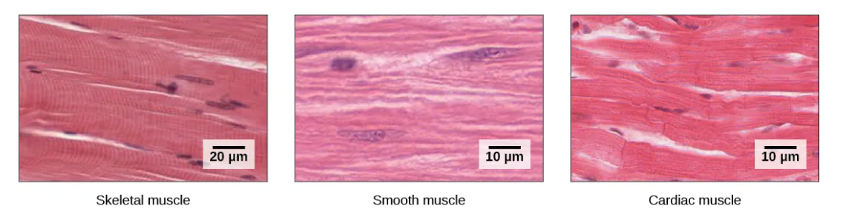

**Procedures**

1. I will review what a muscle is.
2. I will review what a muscle tissue is.
3. I will review what a smooth muscle is.
4. I will review what a skeletal muscle is.
5. I will review what a cardiac muscle is.
6. I will explain the picture (ETP) of the three kinds of muscles.
7. I will record my data, which are my results.
8. I will make my conclusion with my binary.
9. I will discuss my conclusion with my binary.

**Result**

**Conclusion**

Make your conclusion with your binary.

**Open Questions:** E-mail your questions at [numbers115@aol.com](mailto:numbers115@aol.com).

Questions can be related to APEMS (Anatomy, Physiology, Evolutionary Medicine and Military Science). Questions can be pertaining to COVID and other viruses. Questions can be on how to produce rice for all. Questions can be on Mom’s Grassy Farmlands Nuclear Bunkers Rice Complexes and Universities. Finally, questions can be on Mom’s Grassy “Extension”.

Do your best!

**Professor Deauna**