**ACTIVITIES FOR THIS WEEK #2 (Invertebrate Evolution/Vertebrate Evolution/VOIAN Muscle of Vertebral Column—Quadratus lumborum muscle)**

**Overview**

The animal kingdom is composed of multicellular and heterotrophic organisms. Many organisms reproduce asexually, sexually, or both. The invertebrates include the sponges. The sponge has a body with pores. Invertebrates have no backbones.

The vertebrates are animals with backbones. These animals at some stages in their development have a backbone.

**These are the following activities for this week. I revised the Activities For This Week to accommodate any Global Farmer-Engineer joining this course anytime. Also, I revised the Activities For This Week to accommodate any Health Care Provider joining this course anytime as a refresher course.**

**A. Discussion Forum Activities**

**Discussion Forum Activity –**

The Global Farmer Engineers should answer the questions in the Discussion Forum. The Discussion Forum consists of two parts. The first part will be your response to the main question(s). The second part will be your response to your binary.

Answer the Discussion Forum questions for the week by posting to your binary. For Part 1, Military Checkpoint (MC) #1: Explain the anatomy and physiology of the water vascular system. Military Checkpoint (MC) #2: Identify the three groups of mammals and describe each accordingly.

For Part 2, Evolutionary Medicine concept states that mammals share an ancestor with the reptiles. Also, the mammals appeared simultaneously with the dinosaurs. For Part 2, explain the evolution of the mammals.

**B. CONNECTING THE CONCEPTS**

The CONNECTING THE CONCEPTS exercises identify the need to integrate the concepts through the course. You will recognize that learning the concepts is not based upon memorization. Instead, learning the concepts is based on connecting and linking the concepts even if it seems to be of different topics. Let me explain, the CONNECTING THE CONCEPTS exercises act as the threads that unite the concepts throughout the course. You will be using the CONNECTING THE CONCEPTS exercises when you build your Binary Project Paper.

There are five concepts that you have to use in sentences every week. Connecting The Concepts exercise is a critical thinking exercise I designed and I have been using Connecting The Concepts for 30 years now. The five concepts for this week are:

**1. Invertebrate evolution**

**2. Vertebrate evolution**

**3. Placenta**

**4. Cetacea**

**5. Quadratus lumborum muscle**

Post your responses by sending your sentences to your binary.

**C. Binary Project Paper –** Plan your work and create your paper based on the Anatomy, the Physiology, the VOIAN, the Hazards, the Controls and the Military Science concepts involved with the muscle chosen. With regards to the controls, the controls are Engineering Control, Administrative Control, and the use of Personal Protective Equipment. Military Concepts, which are Chess Concepts, are also included in your Binary Project Paper.

You have to research and write a paper on VOIAN and related concepts before the end of this course. Updates will be given every week. The Binary Project Paper is due on the Week of 7/15/24.

For this week, your focus for your binary project paper is **learning the Anatomy of the Muscle you and your binary have chosen**. Work with your binary.

**D. VOIAN Exercises and Laboratory Exercises and Evolutionary Video Exercises**

**VOIAN Exercises**

The **VOIAN Exercise** is my original that I made for my **Boston** Health Careers students. The **VOIAN Exercise** is related to **“dissections”** of the different muscles. The **VOIAN data** that you generated have to be **researched** with your binary. **V** stands for **view**. **O** stands for **origin** (the stationary part of the muscle). **I** is for **insertion** (the opposite end of the muscle that moves). **A** is for **action** (the movement caused by the muscle). Finally, **N** is for **nerve** (the nerve involved in the muscle). This assessment, like the other assessments, in this course, have corresponding rubrics attached to the syllabus to clearly state learning goals and objectives.

There is one movie or video that you have to watch. VOIAN exercises are aligned with the objectives of this course. Watch a movie or a video of your choice and the choice of your binary on the assigned muscle for this week. For this week, the assigned muscle is the **quadratus lumborum muscle**.

The **View** (V) is given. The **V** is posterior.

**V = posterior**

**O =**

**I =**

**A =**

**N =**

**Laboratory Exercise #2**

**Objective**

I will be able to explain the picture (ETP) of the anatomy of a sponge.

**Materials (Sample)**

Professor Deauna’s lecture, Open Educational Resources Journals, Cellphone, and outside

SOURCE: https://courses.lumenlearning.com/wm-nmbiology2/chapter/morphology-of-sponges/

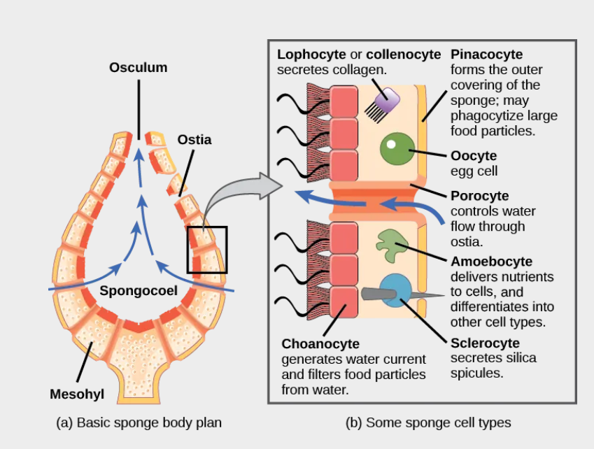

**Procedures**

1. I will review the Phylum Porifera
2. I will review what a multicellular organism is.
3. I will review what a tissue is.
4. I will review the anatomy of a simple sponge.
5. I will review what an evolutionary dead end is.
6. I will explain the picture (ETP) of the anatomy of the sponge.
7. I will record my data, which are my results.
8. I will make my conclusion with my binary.
9. I will discuss my conclusion with my binary.

**Result**

**Conclusion**

Make your conclusion with your binary.

**Open Questions:** E-mail your questions at [numbers115@aol.com](mailto:numbers115@aol.com).

Questions can be related to APEMS (Anatomy, Physiology, Evolutionary Medicine and Military Science). Questions can be pertaining to COVID and other viruses. Questions can be on how to produce rice for all. Questions can be on Mom’s Grassy Farmlands Nuclear Bunkers Rice Complexes and Universities. Finally, questions can be on Mom’s Grassy “Extension”.

Do your best!

**Professor Deauna**